The

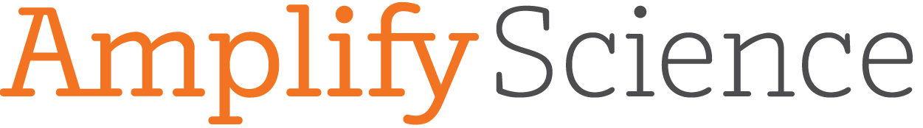
Newsletter

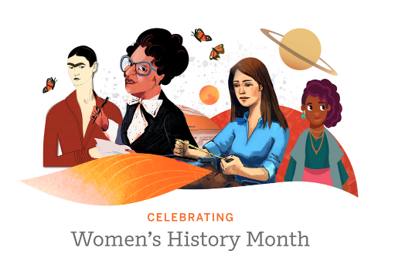

Women’s History Month is here! We encourage you to take this opportunity to celebrate the women highlighted in Amplify Science. Use this Women’s History Month poster and virtual background as you discuss these important leaders with your students.

- Lora Angelova is a chemist who preserves artwork.
- Dr. Grace O'Connell is a scientist who grows new cells.
- Dr. Susan Lynch is a microbiologist who studies the human microbiome.
- Amy Bower is an oceanographer who studies underwater currents.

Amplify Science: Access and Equity

Two overarching conceptual frameworks informed Amplify Science’s approach to ensuring access and equity for all students: Universal Design for Learning and Culturally and Linguistically Responsive Teaching.

Universal Design for Learning (UDL) is a research-based framework for improving student learning experiences and outcomes by focusing on careful instructional planning to meet the varied needs of students. Through the UDL framework, the needs of all learners are considered and planned for at the point of first teaching, thereby preventing follow-up instruction or reducing the need for alternative instruction.

Culturally and linguistically responsive teaching (CLRT) principles emphasize validating and valuing students’ cultural and linguistic heritage and creating positive and nurturing learning environments so that learning is more effective. Amplify Science’s engaging projects, hands-on and interactive experiences, collaborative learning experiences, and frequent student-to-student discussions provide opportunities for all voices to be included. Students are encouraged to express themselves using the language in which they are most comfortable, while also adding science disciplinary language to their language repertoires.

Productive DIscussions: Having a productive science discussion doesn’t just happen. It requires many people to participate and be thoughtful about how they participate. These sentence starters can help you have a productive discussion.

Access the full PDF from WestEd here.

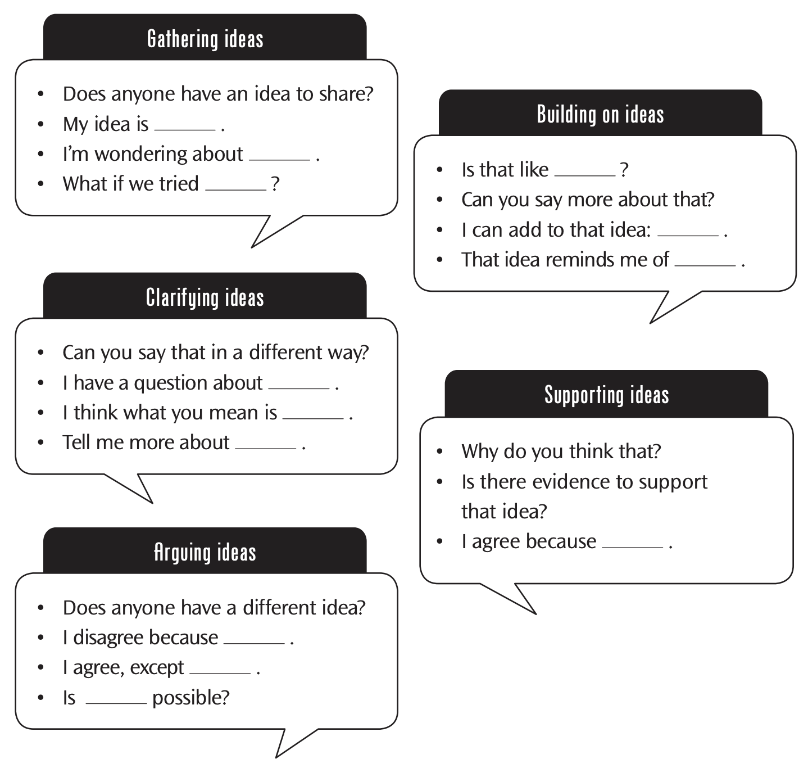

Amplify Science: Embedded and Differentiated Support

Embedded Support:

Amplify Science units and lessons are designed to be universal and flexible in allowing choices; different paths toward goals; and multiple means of engagement, representation, action and expression, and assessment so that all students have an opportunity to learn during lessons and be successful with lesson and unit goals.

All lessons are designed with a range of students in mind, providing multiple points of entry and modalities of learning (e.g. talking to peers, viewing short explanatory videos, reading, writing, conducting investigations, etc.) for students to engage with the content.

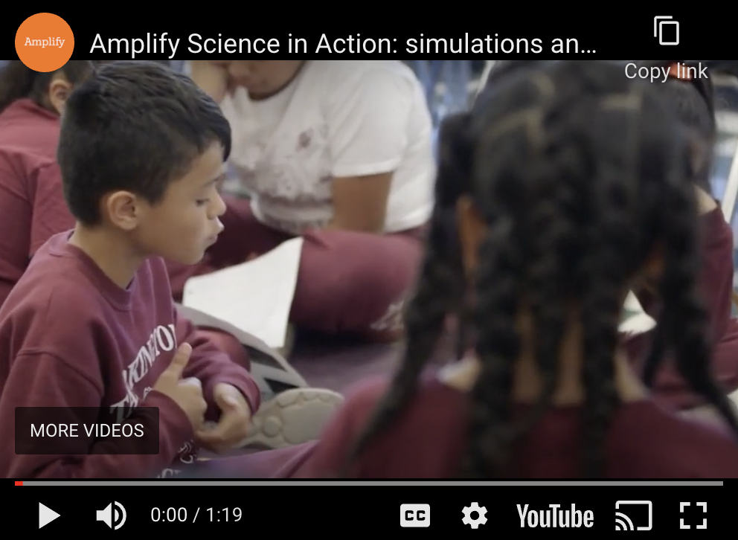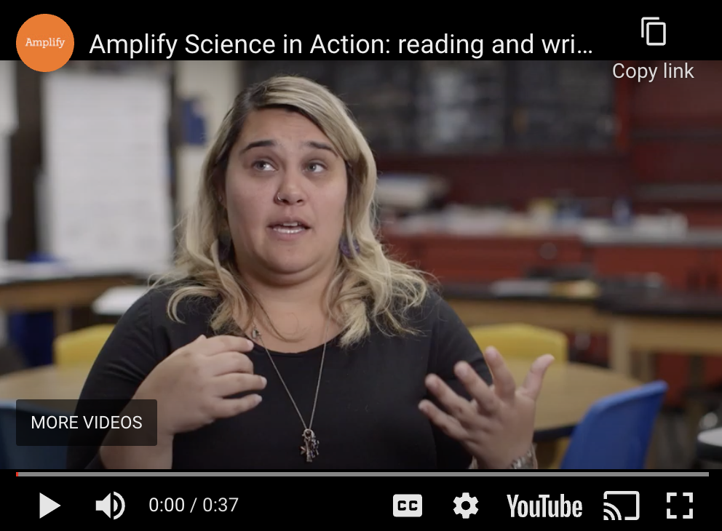

Differentiated Support:

In addition, to support teachers with the decisions they need to make in order to ensure that all students have access to learning, each lesson contains a Differentiation Brief that outlines specific supports for diverse learners, as well as flexible options for adapting lessons according to students’ needs.

Example: Environments and Survival (Lesson 1.3) | Weather Patterns (Lesson 1.4)
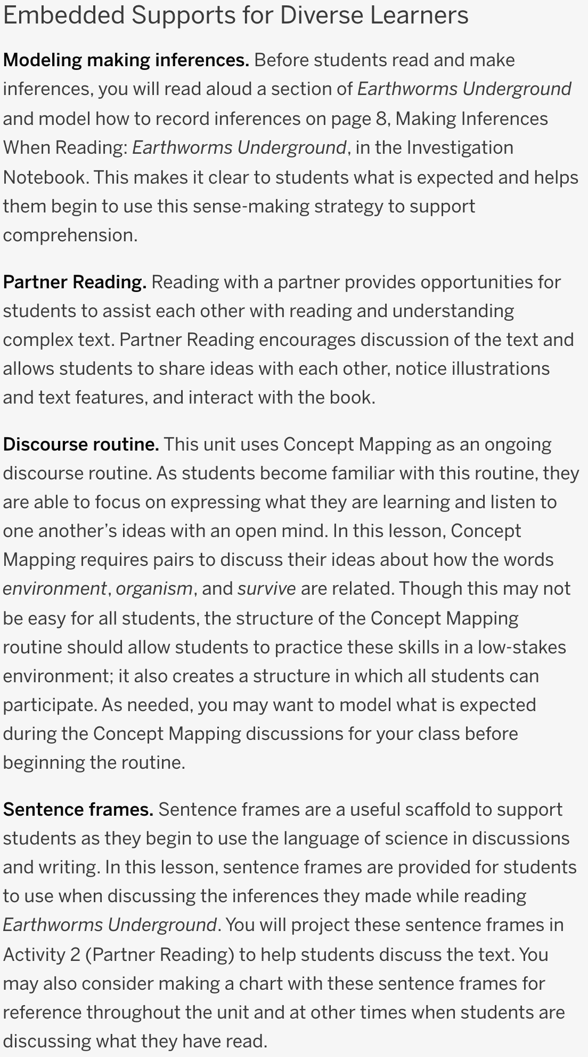 | 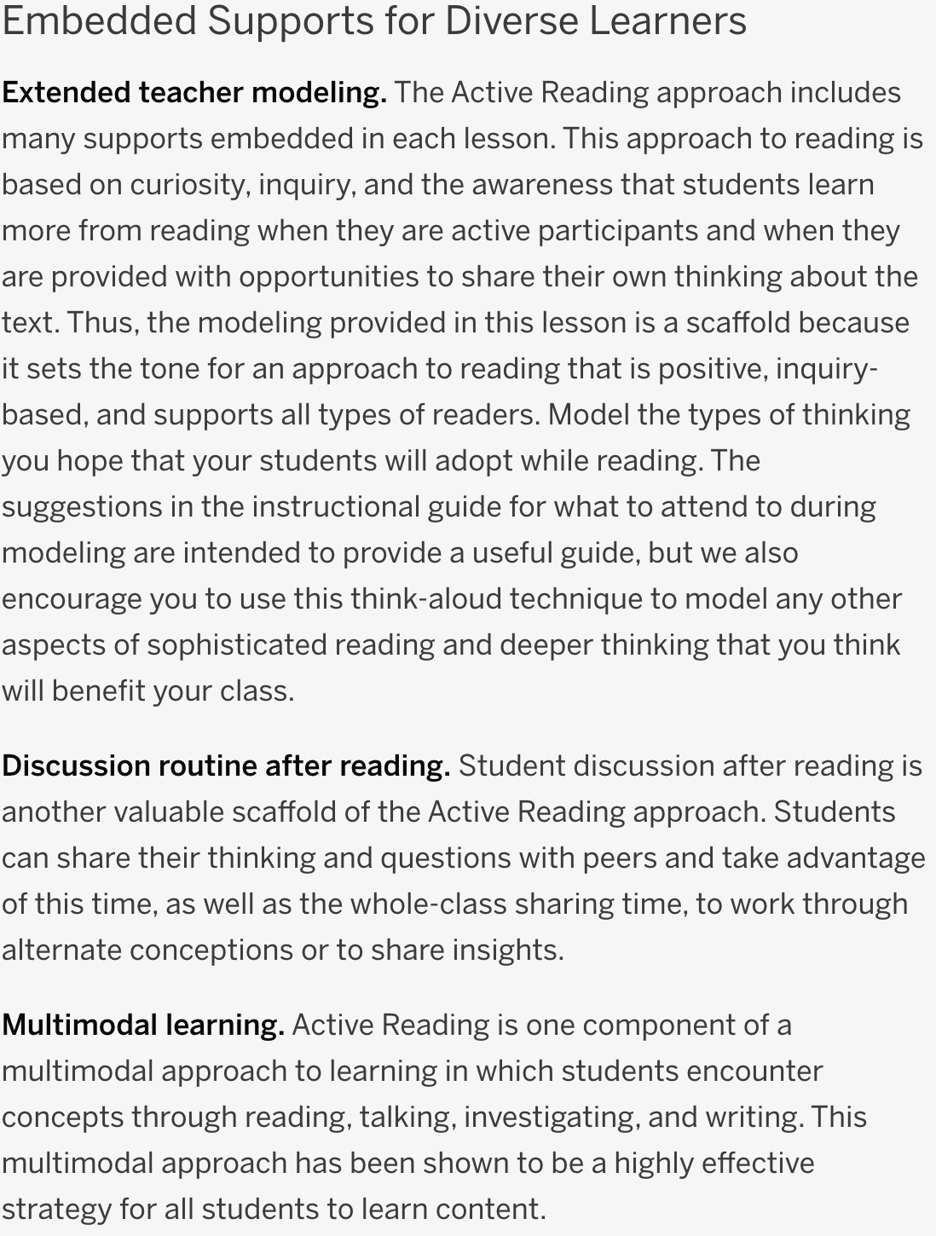

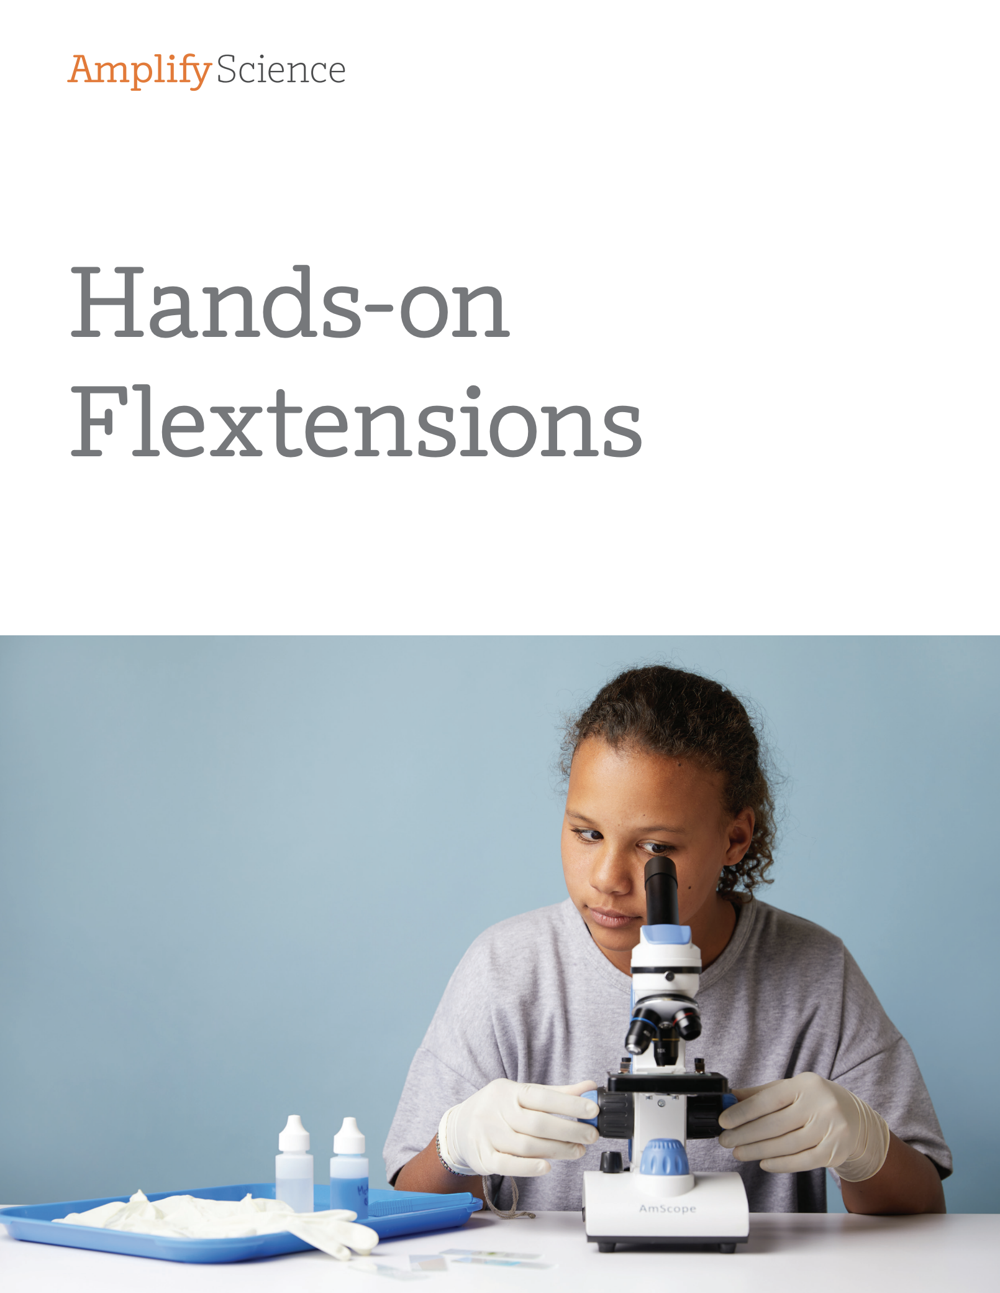
Hands-on Flextensions

There are two kinds of hands-on investigations in Amplify Science. In-lesson investigations are critical to student success
as it is related to the Progress Build or learning progression of
each unit. These activities are accounted for in the pacing of the program.

Flextensions are optional hands-on investigations that give students an opportunity to dig deeper if time permits. These activities offer teachers flexibility in planning to deliver truly multimodal instruction.

Materials referenced in Flextension activities will either be included in the unit kit or easily sourced. Supporting resources such as worksheets will be included in the Amplify digital teacher and student accounts as downloadable PDF files.
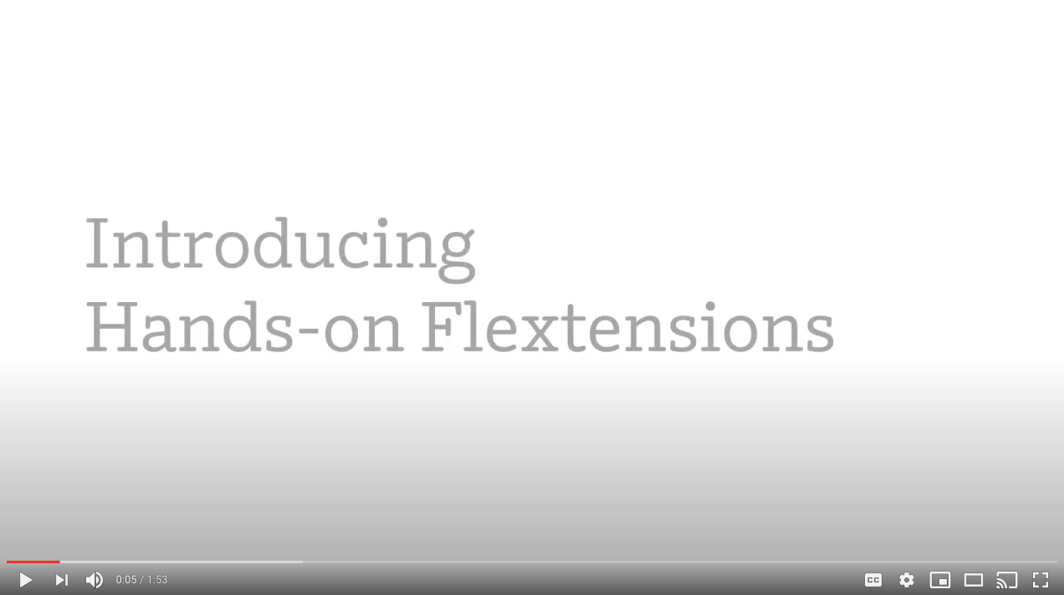
Flextensions Video

Sample list of Flextension hands-on activities

Grade 2

Unit | Flextension title | Activity description
Plant and Animal Relationships | Investigating Sample Study Sites | Over a number of visits, students collect data to analyze the changes that occur in their study sites.

Grade 3

Unit | Flextension title | Activity description
Weather and Climate | Designing Wind-Measurement Tools | Students design, build, and test tools to measure wind direction and wind speed.

Grade 4

Unit | Flextension title | Activity description
Vision and Light | Designing Ear Structures | Students build model ears based on animal ears and test which best detect sounds in different ways.

Grade 5

Unit | Flextension title | Activity description
The Earth System | Modeling Groundwater | Students create and use a physical model of groundwater using cups, colored water, and gravel.

Grades 6-8

Unit | Flextension title | Activity description
Evolutionary History | Squid Dissection | Students dissect a squid and compare the structures they discover to those found in belemnites, prehistoric squid relatives.
Natural Selection | Claw Traits Over Generations | Students conduct a physical model using forks and dry pasta and discover how differences in traits affecting ability to catch food affect rates of death and reproduction, and lead to shifts in traits in a population.
Earth’s Changing Climate | Model Atmosphere and Temperature | Students create a physical model of the atmosphere in a bottle and test the effect of adding carbon dioxide on the temperature.
Plate Motion | Landforms at Boundaries | Students explore and test physical models of plate boundaries using sand and discover how certain landforms can be created at certain types of boundaries.

Calendar
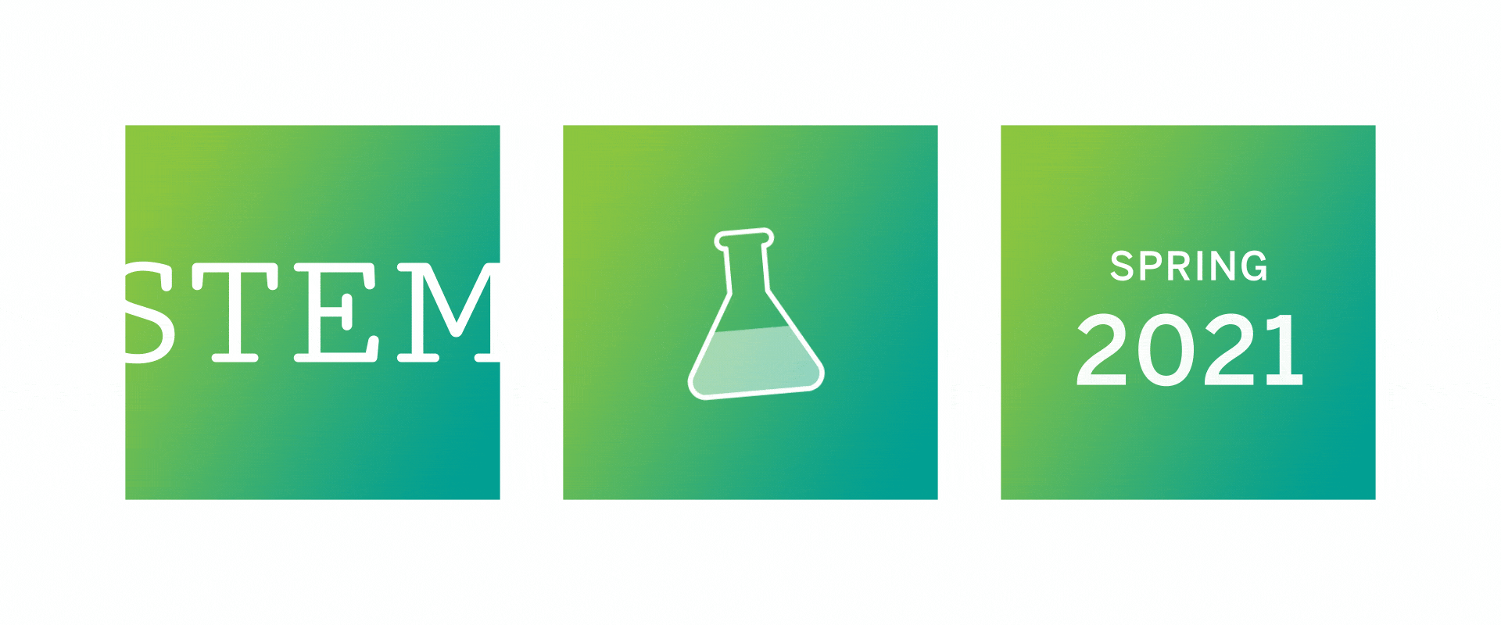
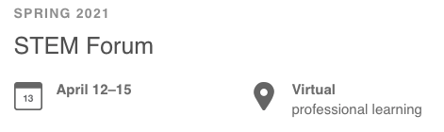

Registration is now open! Grab a math colleague and join our keynote speakers, who will be covering topics like culturally-relevant storytelling, coding and engineering integration, SEL, and more!



- Science and Literacy webinar: Rebecca Abbott of LHS is hosting a webinar on March 22nd called “Science and Literacy Instruction: You Don’t Have to Choose”. K–5 science teachers can register here.
- Science program overview webinars: Our series of bi-weekly program overview webinars continues with two more webinars next week! register here.
- Free Crosscutting Concepts poster download:Spark classroom discussions around which Crosscutting Concepts your students encountered in each lesson with a free poster download!

Advice and Answers
Our customer support team is here to provide technical and instructional support by live chat, phone, or email.
- Get support Monday through Friday, 7 a.m. to 9 p.m. ET, and Sunday, 10 a.m. to 6 p.m. ET.
- Have a question? Contact us.

Latest from our Facebook

The Amplify Science Facebook group is a place for educators to provide each other with support and dialogue about using the program. Join the group and begin collaborating.


Facebook
Instagram
Twitter
LinkedIn
YouTube

